CSE420
Samuel Marrujo
Professor Yu
Lab 03

Plots
In this part of the lab, it was a modification of the original plots function. After changing the function towards y, the resulting image displayed an entirely different function than what was given. Because of this change, I believe I was able to accomplish this task successfully, since there were no errors and the display window was changed. Here are my results for this program:
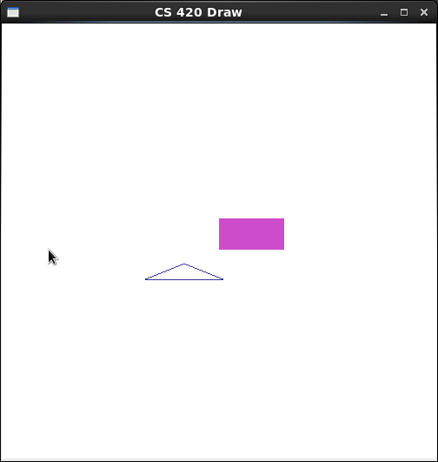

/*
plots.cpp
Demonstrate the drawing of a line using the surface class developed
by T.L. Yu

@Author: T.L. Yu, April 15, 2006

*/
#include <SDL/SDL.h>
#include <stdlib.h>
#include <stdio.h>

#include "draw.h"
#include "surface.h"

using namespace std;

double f ( double x )
{
double y = exp ( -fabs ( x ) ) * sin ( (2) * 3.1415926 * x );

return y;
}

int main()
{

const int VWIDTH = 640;
const int VHEIGHT = 480;

const Point center ( VWIDTH/2, VHEIGHT/2 ); //center of screen
Surface surf( VWIDTH, VHEIGHT, (char *) "draw_line" );

surf.clearScreen(); //clear screen
surf.updateSurface();
SDL_Delay ( 1000 ); //dealy one second, just for demo

surf.setBackgroundColor ( 0xe0, 0xe0, 0xe0 ); //set background to grey

//draw a line
surf.setColor ( 0xff, 0, 0 ); //using red color

int sx, sy;
double x, y, a, b, c, d;
a = VWIDTH / 3;
c = 0;
b = -VHEIGHT / 2.0;
d = VHEIGHT / 2.0;

x = 0.0; //initial position
y = f ( 0.0 );
sx = (int) ( a * x + c );
sy = (int) ( b * y + d );
surf.moveTo ( sx, sy );

for ( x = 0; x < 4.0; x += 0.005 ) {
y = f ( x );
sx = (int) ( a * x + c );
sy = (int) ( b * y + d );
surf.lineTo ( sx, sy );
}

surf.updateSurface();
SDL_Delay ( 10000 ); //display 10 seconds before exit
return 1;
}
Hook
Lastly, in the Hook program, we are to use the turtle algorithms discussed in class to form polygons, arcs, and circles. Due to the screen-shots given and the code supplied, I was able to successfully complete the Lab. So, the outcome of the programs led to the following screen shots in the program:

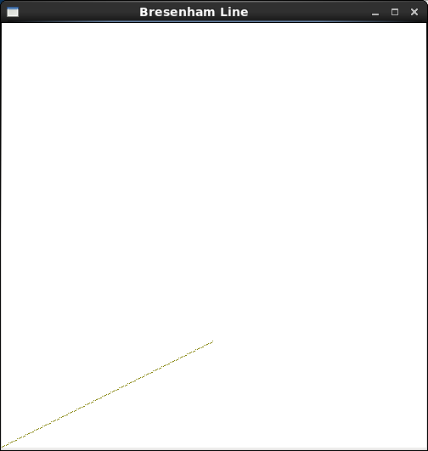

/*
draw_demo.cpp
Demonstrate the use of turtle grapics using the surface class developed
by T.L. Yu
edited by Samuel Alex Marrujo

@Author: T.L. Yu, April 15, 2006
Revised on 2013/09/30
*/
#include <SDL/SDL.h>
#include <stdlib.h>
#include <stdio.h>

#include "draw.h"
#include "surface.h"

//draw a hook
void draw_hook ( Surface &surf, int L )
{
surf.forward ( L, 1 );
surf.turn( 90 );
surf.forward ( L/5, 1 );
surf.turn ( 90 );
surf.forward ( L/3, 1 );
}

void draw_arc ( Surface &surf, int L ) {

for(int i = 0; i < 6; ++i) {
surf.forward(L,1);
surf.turn(15);
}
}

//draw a star pattern
void draw_star( Surface &surf, int L )
{
for ( int i = 0; i < 5; ++i ) {
surf.forward( L, 1 );
surf.turn( 144 );
}
}

//draw an n-sided regular polygon
void draw_polygon ( Surface &surf, int n, int radius, float rotAngle )
{
if ( n < 3 ) return; //bad number of sides
int cx = surf.getCP().x;
int cy = surf.getCP().y;
double angle = rotAngle * 3.14159265 / 180; //initial angle
double angleInc = 2 * 3.14159265 / n; //angle increment
surf.moveTo ( ( int) (radius * cos( angle ) + cx),
( int ) ( radius * sin ( angle ) + cy ) );
for ( int k = 0; k < n; k++ ) { //repeat n times
angle += angleInc;
surf.lineTo ( ( int) (radius * cos( angle ) + cx),
( int ) ( radius * sin ( angle ) + cy ) );
}
} //draw_polygon

//draw rosette with N-sided polygon
void rosette (Surface &surf, int N, int radius )
{
if ( N < 3 ) return;
Point pt[N+1];

int cx = surf.getCP().x;
int cy = surf.getCP().y;
double angle = 0; //initial angle
double angleInc = 2 * 3.14159265 / N; //angle increment
pt[0] = Point ( ( int) (radius * cos( angle ) + cx),
( int ) ( radius * sin ( angle ) + cy ) );
for ( int k = 1; k < N; k++ ) { //repeat n times
angle += angleInc;
pt[k] = Point ( ( int) (radius * cos( angle ) + cx),
( int ) ( radius * sin ( angle ) + cy ) );
}
for ( int i = 0; i < N - 1; i++ ) {
for ( int j = i + 1; j < N; j++ ) {
surf.moveTo ( pt[i] ); //connect all vertices
surf.lineTo ( pt[j] );
}
}
} //rosette

int main()
{

#ifndef ARM
const int VWIDTH = 640;
const int VHEIGHT = 480;
#else
const int VWIDTH = 320;
const int VHEIGHT = 240;
#endif

const Point center ( VWIDTH/2, VHEIGHT/2 ); //center of screen
Surface surf( VWIDTH, VHEIGHT, (char *) "Draw_demo" );

surf.clearScreen(); //clear screen
surf.updateSurface();
SDL_Delay ( 1000 ); //dealy one second, just for demo

surf.setBackgroundColor ( 0xe0, 0xe0, 0xe0 ); //set background to grey

//draw a hook
//surf.setColor ( 0xff, 0, 0 ); //using red color
//surf.moveTo ( center ); //move to center of screen
//surf.turnTo ( 0 ); //points horizontally
//draw_hook ( surf, 180 );

//draw a star
//surf.setColor ( 0, 0xff, 0 ); //using green color
//surf.moveTo ( center.x + 90, center.y );
//surf.turnTo ( 0 ); //points horizontally
//draw_star ( surf, 50 );

//draw an octagon
surf.setColor ( 0x00, 0, 0 ); //using black color
surf.moveTo ( center.x, center.y - 90 );
// draw_polygon ( surf, 8, 40, 0 ); //draw an octagon
draw_polygon ( surf, 6, 40, 0 ); //draw a hexagon

surf.setColor ( 0xBF, 0, 0 );
surf.moveTo (center.x, center.y - 180 );
draw_polygon ( surf, 32, 40, 0 ); //draw a circle

surf.setColor ( 0xFF, 0, 0 );
surf.moveTo (center.x-60, center.y-10);
surf.turnTo(0);
draw_arc(surf, 60); //draw an arc

//draw an 8-sided rosette
//surf.setColor ( 0, 0, 0 ); //using black color
//surf.moveTo ( center.x - 90, center.y + 90 );
//rosette ( surf, 8, 50 );

surf.updateSurface();
SDL_Delay ( 5000 ); //display 5 seconds before exit
return 1;
}

